How to forward a GUI from a container to a windows host system

The following is a tutorial for how to forward a GUI from a container to a windows host system. This tutorial specifically focuses on forwarding an image from a container to your host system and opening it with eye of gnome. If you don’t already have Docker desktop and A windows x server alternative, I recommend you download those now. Docker desktop can be found here: <https://www.docker.com/products/docker-desktop/> and my X server alternative of choice, VCXsrv, can be downloaded from here: <https://sourceforge.net/projects/vcxsrv/> . This tutorial will also require a text editor and png/jpg of your choice so make sure to get one of each if you don’t already have one.

In order to make a container we’ll need to create a Dockerfile that gives the container instructions, if you have any confusion about Dockerfiles or would like to learn more about them I recommend this article <https://docs.docker.com/engine/reference/builder/> . Make a new folder in your text editor of choice that includes a file simply named “Dockerfile” and a copy of the jpg or png you’d like to open. The following is all the text you’ll need inside of your Dockerfile.

#tells docker that you want your container to operate on Cent OS 7

FROM centos:7

#tells your container to install eog (our image viewing software) and dbus (a program that helps your container and host communicate)

RUN yum -y install eog dbus-x11

#copies a jpg of your choice to the home file on your container

COPY yourFileNameHere.jpg /home

#Checks if a system has a universally unique ID, creating one if a system doesn't have one already. This helps with communicating between host and container

RUN dbus-uuidgen > /var/lib/dbus/machine-id

#tells your container to open eog (a photo viewing software), and gives the container the location of the image you'd like to open

CMD ["eog", "/home/(yourFileNameHere).jpg"]

Once you’ve added this code to you’re docker file, adjusted it to match the name of your picture and added that image to your project folder you can save your project file and close your text editor. The next step is to open VCXsrv with the following settings.

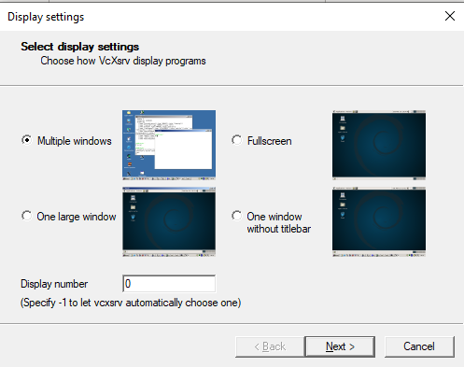

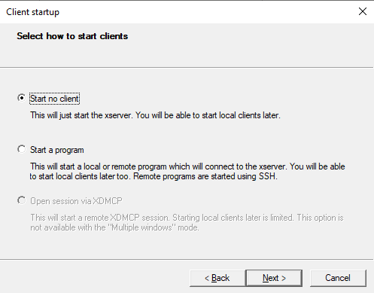

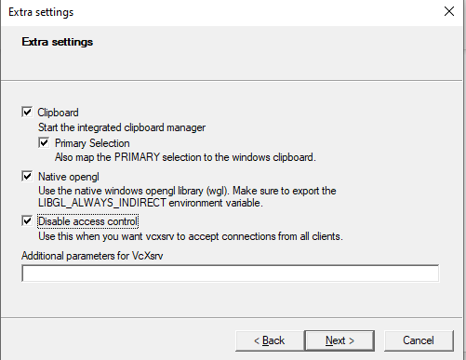

Make sure that the Disable access control box is checked on the last screen, if it isn’t your container will be denied access to forward to your host system by windows firewall. After you’ve ran VCXsrc open Docker desktop and powershell as an admin. Once both are open use the cd command along with the file address of the folder you made earlier for your Dockerfile and picture. It should look something like this.

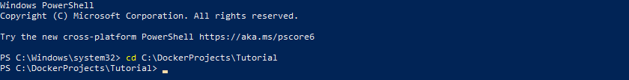

After navigating to the folder the Dockerfile is in run the “docker build -t (image name here) .” command to build an image of your docker file. Note the period that comes after what you’d like to name your docker image, the command won’t work properly without it. Once this command is ran the powershell will start a series of operations in order to construct your image, this process may take a second.

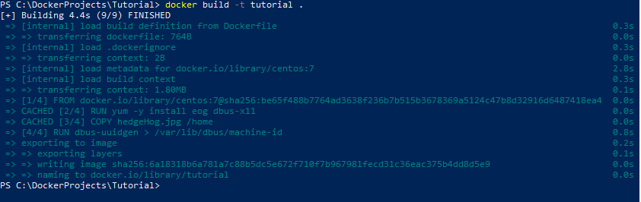

And voila, an VCXsrv window with your picture should pop up on your display just like that

